**Hardware Connections For Temperature Monitor**

In the previous lesson, we have learned about LM35 Sensor. In this lesson, we will learn how to connect LM35 Sensor to Bolt.

**Hardware required**

* The Bolt Wifi module
* 3 female to male wire
* Temperature Sensor: LM35 sensor

**Connecting the LM35 sensor to the Bolt**

Step 1: Hold the sensor in a manner such that you can read LM35 written on it.

Step 2: In this position, identify the pins of the sensor as VCC, Output and Gnd from your left to right.

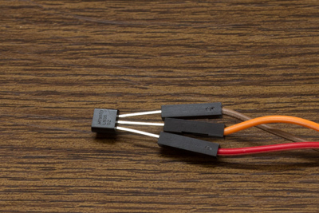

In the above image, VCC is connected to the red wire, Output is connected to the orange wire and Gnd is connected to the brown wire.

Step 3: Using male to female wire connect the 3 pins of the LM35 to the Bolt Wifi Module as follows:

* VCC pin of the LM35 connects to 5v of the Bolt Wifi module.
* Output pin of the LM35 connects to A0 (Analog input pin) of the Bolt Wifi module.
* Gnd pin of the LM35 connects to the Gnd.

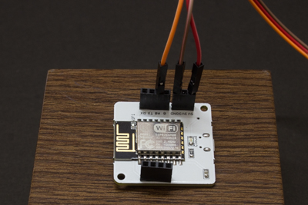

The final circuit should look like the image below:

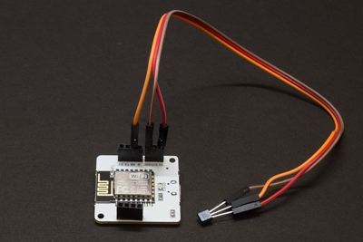

That's it. In the next lesson, we will learn about Twilio and how to collect data from LM35 sensor.